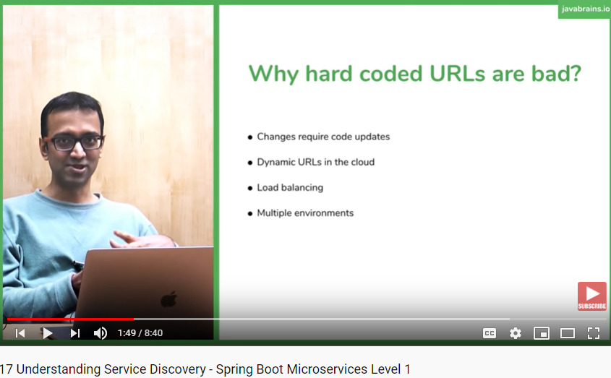

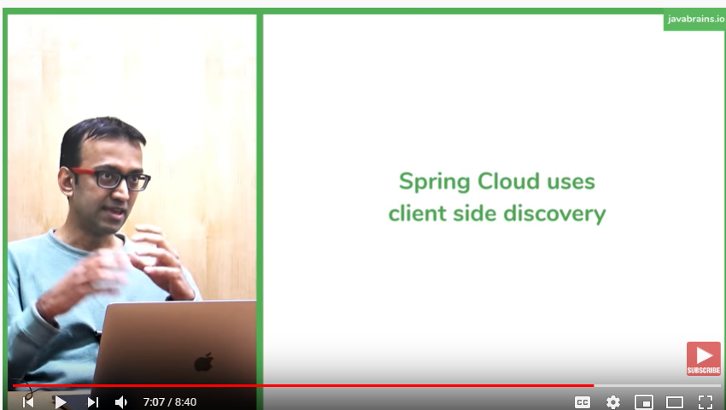

As of Sprig 5.0, webclient is recommended to use . rest template will be deprecated.

Webclient uses asynch way of communication, calling .block() on webclient makes it as sync like rest template but in either way webclient is recommended by Spring

Eureka is client side discovery server, open sources from Hetflix

Spring boot comes with two dependency

Eureka client dependency for

Whatever application you want to do the discovery or publish the server

Eureka Server dependency

Client side service discovery looks like working as server side service discovery because of abstraction eureka client provides and it is used by rest template . so developer do not came to know the extra hop , api does it internally .

@LoadBalance does service discovery in load balanced way

Using this annotation , restTemplate is said that what service detail I am passing is just a hint to service so do the discovery.

The Srring wrapper for all Netflix open source project (eureka for ex) is part of spring cloud family

@ enable Eureka client

 annotation was earlier mandatory but with the latest version it is no more required .

 @ enableeurekaserver is at server .

How did the client find where Eureka server when is how did it know where it is eregister

 right now we have use the default port for Eureka server certificate  so it tries to default port  it works.

 Configure it to the properties file.  Property like Eureka server and then pass the  address  hello han han Puja personalwhere is it